Through the Panama Canal by Ferry
By Chuck Simon, ACC, President, Starview Adventures,
an Independent Affiliate of Travel Network/Vacation Central

Aboard the MSC Divina, October 18, 2022, a Day at Sea
A young boy sits in front of a tub of water about ¾ full, playing with his toy boat in 1883. He pulls the plug, watching his little ship slowly descend as the water drains from the tub. He then plugs the drain and starts to refill the tub, smiling as his vessel quietly ascends to almost the height of the tub. Little does he realize that he will be designing the Panama Canal 20 years hence, using the same principles.

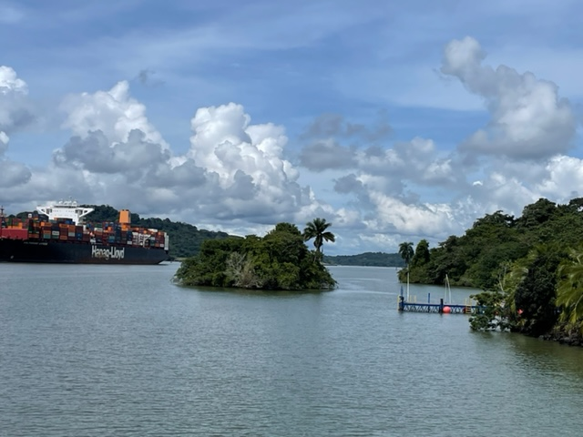
The Panama Canal is mostly a beautiful, lazy river.

As I did aboard the MSC Poesia in November 2009, yesterday I savored the beauty and marveled at the engineering and construction feats that produced the Panama Canal. I was aboard a ferry crossing from East to West as the highlight shore excursion offered by the MSC Divina on its 13 day Southern Caribbean voyage to and from Florida. With previous ports of call visiting Jamaica, Ocean Key, Aruba, Columbia, and Costa Rica, the cruise had already earned its stripes. Now the prospect of actually traversing the Canal promised to be the crowning adventure.
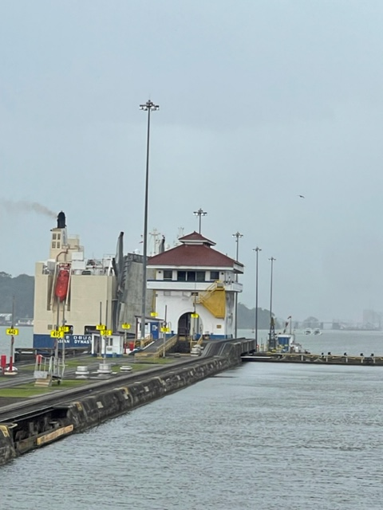  Approaching the Pedro Miguel Locks | 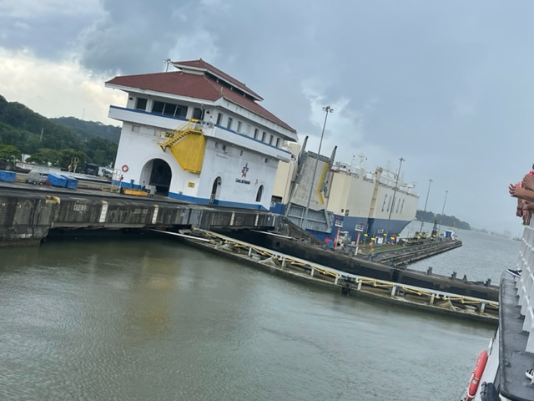  Beginning our descent of 23 feet

While many cruise lines move their cruise ships through the Canal, MSC, on this cruise, docked in Colon, the main port on the Atlantic side of Panama. Passengers crossing on a large cruise ship in either direction certainly enjoy the comforts of their splendid ship, but face returning to their home port by air, with the attendant additional costs and time associated with more travel. MSC’s approach was to offer a shore excursion to accommodate crossing the Isthmus of Panama in both directions in a single day.
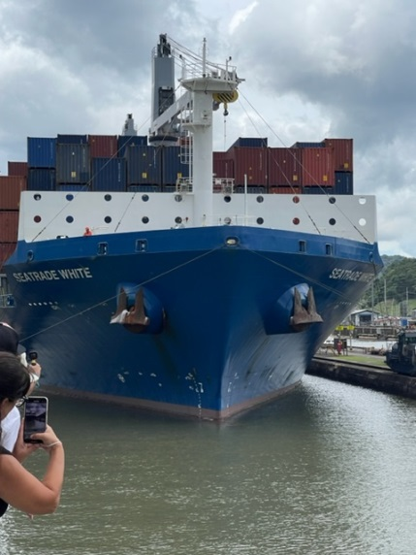
Medium size container ship making the crossing with us

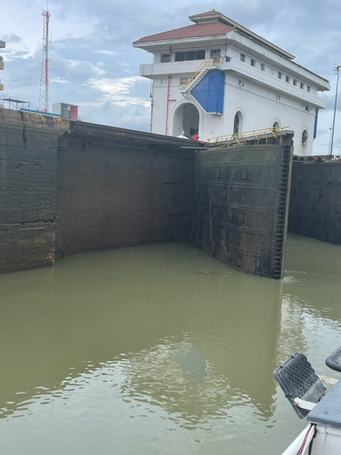  Nearing the bottom of our descent | 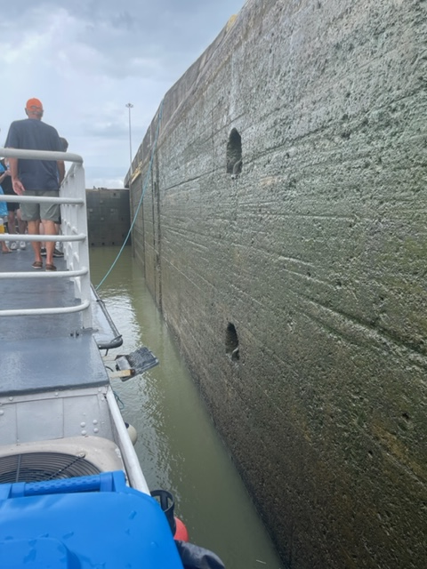  So close you could reach out and touch!

Shoreline to shoreline, the Canal is a mere 50 miles across. The overland route was known to the Spanish explorers of the 16th century, and is now a road parallel to the Canal. In fact, King Charles V, the Holy Roman Emperor and King of Spain, ordered a survey and proposed building a canal across the Isthmus of Panama in 1534. He was a man 4 centuries ahead of his time. Our excursion commenced with a reasonably short bus ride through the rainforest taking us about half way. It’s an average 9 ½ hour journey to fully traverse the Canal, concluding in Panama City on the Pacific side of Panama. Our bus excursion enabled us to experience 2 of the 3 main locks on the canal and complete the crossing by ferry in about 4 ½ hours. An hour and a half later, we were back on the ship via that same historic road.
The ferry ride was unique and provided for a more intimate experience than on a large cruise ship. If you were foolish enough, you could reach out and touch the walls of the locks as you descended. Without touching, you were still close enough to fully appreciate the massive engineering prowess it took to build the Canal. Our tour guide was a walking encyclopedia of amazing facts about the Canal, the old locks, and the new modern locks, accommodating way larger ships, built just 7 years ago.
Some interesting facts:
- 38,000 people died during construction, mostly from malaria, yellow fever and other diseases endemic to the region.
- The Toll for a cruise ship is over a million dollars. Charges used to be by number of cabins, and now are determined by weight. Cargo ships are 6 figures depending on how many containers.
- The new lock channel, which is much deeper and wider, can accommodate a 50,000 container ship at a price up to about $1.4 million. Still way cheaper than going around South America for 21 days!
- The old lock channel continues to be used for smaller ships holding up to 15,000 containers and small craft like our ferry,
- Someone swam the Canal in 1928, they weighed him and charged him 36 cents - the record!
The Panama Canal is definitely a bucket list trip for your clients. The big choice is deciding whether to cross by cruise ship, or by ferry. Either one is guaranteed to be a memorable experience they’ll rave about to others, so make sure you stock them up with plenty of your business cards!

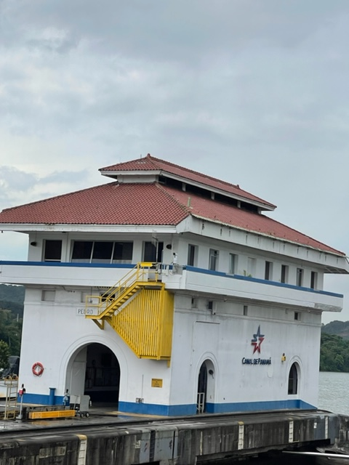

Panama, and Costa Maya, on the Yucatan in Mexico.

